

**Sporty Shoes Application**

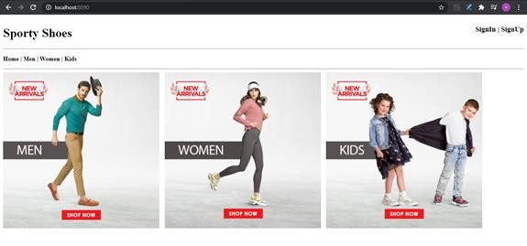

Homepage Of Sporty Shoes

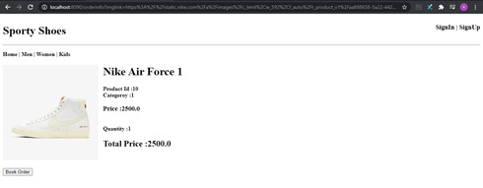

**Booking Of Shoes**

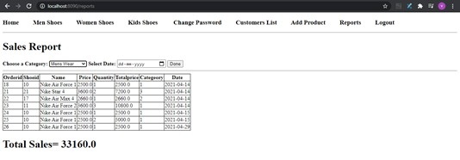

**Record Management For Admin**

=================== THE END ===================